7 September 2010version

Japan-Korea EIA Workdhop Program (for Korean delegates)
Title: Biodiversity and EIA
Date: PM13:30-17:30 17th (Fri) September 2010
Sponsor: JSIA, Nagoya University EcoTopia Science Institute
Venue: Nagoya university (Higashiyama campus), IB-014 room of Integrated Building “IB電子情報館IB-014”
Language: English (no translation)

“Lunch meeting“ 11:45- (at IB-012 room of Integrated Building)

< Japan-Korea EIA WS >
Opening address
13:30: President of JSIA and KSEIA
- JSIA’s President : Shigeru Kashima (Chuo University)
- KSEIA's President : Myungjin Kim (National Institute of Environmental Research)
Special Session: Chinese guest speakers
13:40: Strategic Environmental Assessment in China
- SEA Legislation and Administration in China (Dr.Li Tianwei, MEP)
- SEA Methodology and Practice in China (Dr.Li Wei, Beijing Normal University)

Session I: Biodiversity policy and EIA
Chair: Prof. Jong Ho Lee (Cheongju University) and Prof. Akira Tanaka (Tokyo city University)
14:10: Prof. Kiichiro Hayashi (EcoTopia Science Institute Nagoya University)
"World Trend of Biodiversity Policy and Environmental Assessment"
14:30: Prof. Jaeyong Choi and Eunyoung Park (Chungnam National University)
"CBD and Nature Aspects of EIA"
14:50: Q and A

Session II: Impact assessment for Biodiversity
Chair: Prof. Kiichiro Hayashi (Nagoya University) and Dr. Myungjin Kim (National Institute of Environmental Research)
15:00: Prof. Sang-Don LEE (Ewha Womans University) and Dr.Paik-ho Roh (Korea Environment Institute)
"Construction of alternative habitat for endangered species of waterbirds in the western coastal areas of Incheon"
15:20: Prof. Akira Tanaka (Tokyo City University) and Maiko Yoshizawa (IGES)
"HEP application to EIA in Japan –Its implication for Biodiversity Offset"
15:40: Q and A

Break 15:50-16:00

Session III: Impact assessment for Biodiversity: Cases
Chair: Dr.Jong-Gwan Jung (CDI) and Prof. Takehiko Murayama (Waseda University)
16:00: Ms. Noriko Shimizu (FoE Japan)
"Sakhalin Oil and Natural Gas Development and Biodiversity Conservation"
16:20: Prof. Changwan Seo (University of Seoul)
"Biodiversity Conservation and National Park Management"
16:40: Q and A
SessionIV: Panel discussion
16:50: Chair: Prof. Kiichiro Hayashi (Nagoya University) and Dr. Jong-Gwan Jung (CDI)
Prof.Jaeyong Choi
Prof. Sang-Don LEE (Ewha Womans University)
Prof. Akira Tanaka (Tokyo City University)
Ms. Noriko Shimizu (FoE Japan)
Prof. Changwan Seo (University of Seoul)

17:20：Closing remark
Prof. Akira Tanaka (Chairman of International Exchange Committee of JSIA)

17:45-19:30: Reception (Nanamitei “七味亭”)

19:40-21:00: Tripartite meeting (at IB-012 room of Integrated Building)

Access to Nagoya University
To Higashiyama Campus
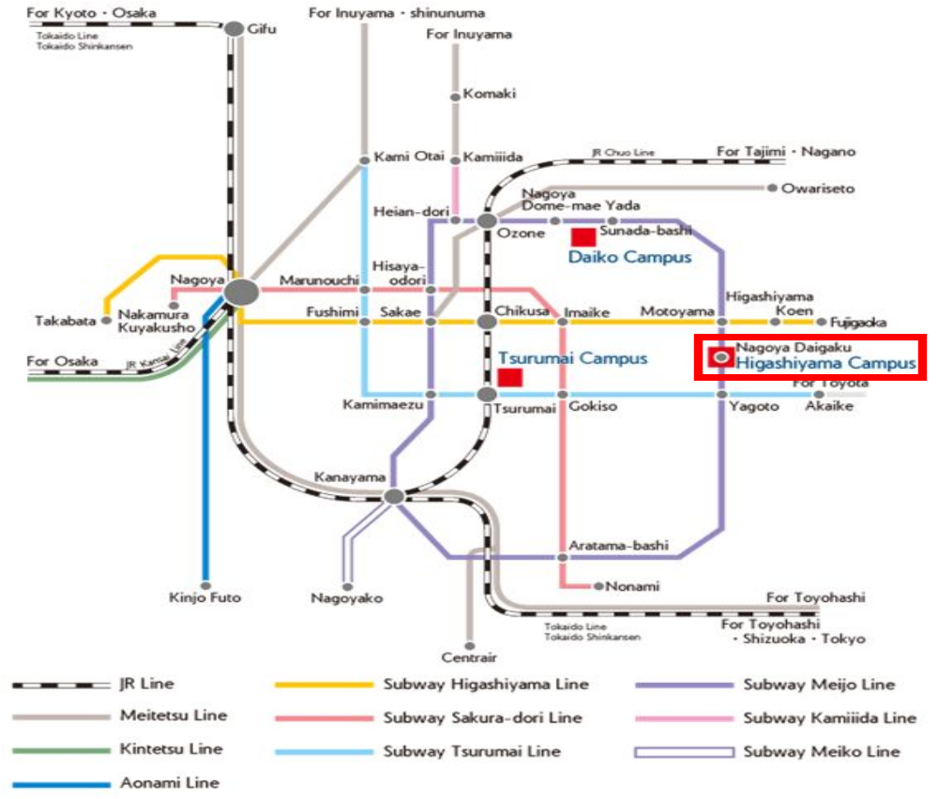
From Nagoya Station: Take the Subway Higashiyama Line to Motoyama Sta. (15 minutes), then transfer to the Subway Meijo Line to Nagoya Daigaku Sta. (Higashiyama Campus is just off the subway exit.).
From Centrair (Central Japan International Airport): Take the Meitetsu Line to Kanayama Sta. (30 min.), then transfer to the Subway Meijyo Line to Nagoya Daigaku Sta. (21 min.).
To Nagoya Station
From Centrair (Central Japan International Airport): Take the Meitetsu Line (30 min.) or the airport bus (60 min.).
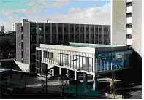
Integrated Building

Venue: Integrated Building “IB電子情報館”
2 minutes from the Exit 3 of Nagoya Daigaku Statation (Subway Meijo Line).
(Venue of convivial party: Nanamitei “七味亭”)

Inside Integrated Building
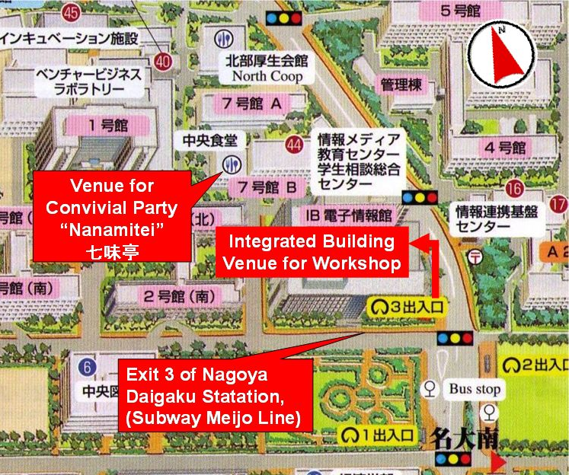
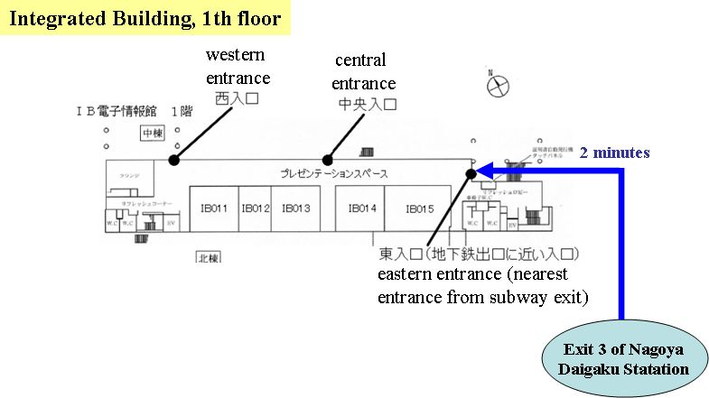
-On Sep. 17th, please come to IB-012 room at 11:45 for lunch meeting.
-Please come here after “Reception” for tripartite meeting.

